# Installation Procedure

Step 1: Need to Copy the Database (VVSLibDB.MDB) from CD (Folder DB) to C:\VVSLib\DB

Step 2: Need to setup ODBC

Control Panel – Admin Tool --- Data Source (ODBC)

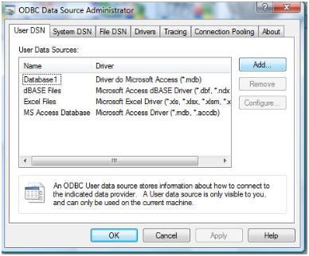

Click on “Add”

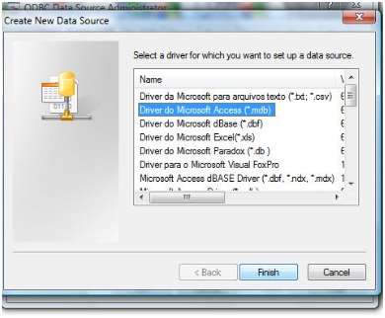

Driver do Microsoft Access (*.mdb) --- > Finish

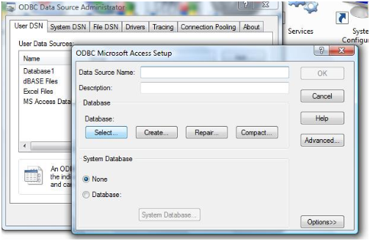

Select Database

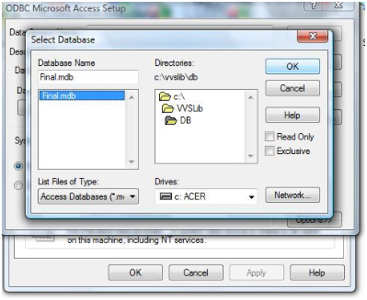

Select “Final.mdb” from C:\VVLib\DB and **give the Data Source Name “Final”, exactly this word.**

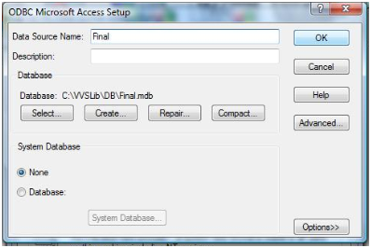

Complete the activity by Clicking “OK”

Step 3: Need to Copy the Program from CD (Folder Prog) to C:\VVSLib\Prog

Step 4: Check the permission (attribute) of the Database file, It should not be in Read Only Mode.

Step 5: Start BlueJ

Step 6: Open Project “Prog”

Step 7: Only “admin” login will work with password “ADM”

Step 8: Change the Password of “Admin” account, immediately after login

Step 9: Create users with type Librarian to start transaction

# Operation Manual / User Guide

## How to Start

1. Start the application with “admin” login [Specified in Installation Procedure Section]
2. Create login for Librarian (User Account with Type “Librarian”)
3. Logout from the system
4. Re-login as Librarian User
5. Create / update Books detail (Add Books Option)
6. Create / update Reader Detail (Add Reader Option)
7. Capture transaction of book using “Book Issue” / “Book Return” options
8. If case any Reader is no more active, modify the “Reader Master”
9. In case any book is not in readable condition, modify the “Book Delete”
10. In case book is lost, capture the transaction in “Book Delete”
11. In case of any Delete Option use “Remark” field to capture detail

## How to Create User

1. Start the application with “Admin” login [Specified in Installation Procedure Section]
2. Go to Maintenance Menu then “New User”

## How to Update Book Master

1. Start the application, and login as Librarian (user with Librarian Type)
2. Go to Maintenance Menu then “NewBook”

## How to Update Reader Master

1. Start the application, and login as Librarian (user with Librarian Type)
2. Go to Maintenance Menu then “New Reader”

## How to Capture Book Issue

1. Start the application, and login as Librarian (user with Librarian Type)
2. Go to Transaction Menu then “Book Issue”

## How to Capture Book Return

1. Start the application, and login as Librarian (user with Librarian Type)
2. Go to Transaction Menu then “Book Return”

## How to Capture “Book Lost”

1. Start the application, and login as Librarian (user with Librarian Type)
2. Go to Master Menu then “Delete Book”

## How to Change Self Password

1. Start the application
2. Go to Maintenance Menu then “Change Password”

## How to Change The Password For Others

1. Start the application, and login as Adm
2. Go to Maintenance Menu then “Change Password ”